ABORIGINAL GRINDING STONES

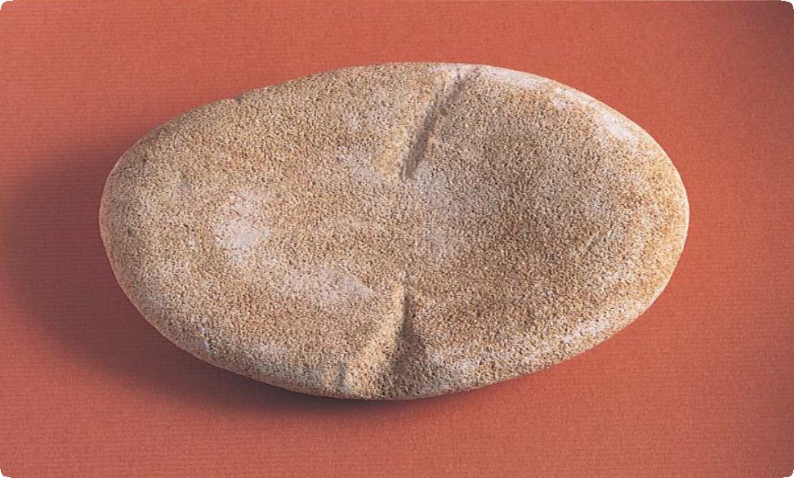

Large grinding stone damaged by agricultural equipment

# What are Aboriginal Grinding Stones?

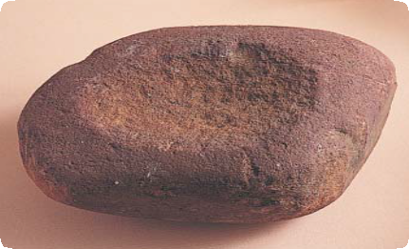

Place Identification

Mini Poster 9

**Characteristics**

* Grinding stones are usually made from abrasive rocks such as sandstone or coarse-grained basalt or quartzite.
* The stones are sometimes found upside down, with the grinding surface facing the ground to preserve it from the weather. Upper and lower grinding stones will not necessarily be found together.
* Smooth river pebbles sometimes resemble grinding stones. If you look closely, the surface of a river pebble has tiny impact marks caused by

collisions with other pebbles in the river. The surface

of a grinding stone has many scratches caused by abrasion but feels smooth.

Lower Stones

* Stones range in size, from very small (150 millimetres across) to very large

(700 millimetres across). They can weigh several kilograms.

continued 2nd side

Grinding stones are slabs of stone that Aboriginal people used to grind and crush different materials. Bulbs, berries, seeds, insects and many other things were ground between a large lower stone and a smaller upper stone.

**Where are They Found?** Grinding stones are usually found where Aboriginal people lived and

camped. For example, they have

been found in shell middens and rock shelters, and at open camp sites and rock art sites. They are common in museum and private collections.

# How Did Aboriginal People Use Grinding Stones?

Grinding stones were among the largest stone implements

of Aboriginal people. They were used to crush, grind or pound different materials.

A main function of grinding stones was to process many types of food for cooking. Bracken fern roots, bulbs, tubers and berries, as well as insects, small mammals and reptiles, were crushed and pulped on grinding stones before cooking. Some types of food are poisonous in their natural state, and could only be eaten after being crushed and washed.

Milling seeds on large flat grinding stones was common in the drier areas of Australia, but less common in Victoria. Leaves and bark were crushed on grinding stones to make medicines.

Aboriginal people also used small grinding stones to crush soft rocks and clays (such as ochre) to make pigments. The pigments were used to decorate bodies for ceremonies, to paint rock art, and to decorate objects such as possum skin cloaks and weapons.

Rocky outcrops are rare in some regions, so the Aboriginal people imported slabs of suitable stone. But large grinding stones were rarely moved. Aboriginal people carried as little as possible when they moved camp, and they often left heavy items such as grinding stones as permanent camp ‘furniture’ to be used on the next visit.

# Why are Aboriginal Grinding Stones Important?

Grinding stones were developed in south east Australia during the last Ice Age, about 15,000 years ago. Conditions were much drier then, and grinding stones allowed people to live in areas where food was limited.

Grinding stones help us learn about the size of past Aboriginal

populations in different regions, their foods, and their reactions to great changes in climate. The origin of some stones is known, which helps us trace the movements of people and their social connections with other regions.

Grinding stones are an important link for Aboriginal people today with their culture and their past.

# Are Aboriginal Grinding Stones under Threat?

Natural processes such as wind and water erosion may disturb grinding stones, but human interference poses the greatest threat. Ploughing, development and any earthworks may disturb Aboriginal places Ploughing in particular can break or cut stones.

Grinding stones are unmistakable Aboriginal artefacts, and many have been collected as souvenirs. Flat stones have even been used for

dry stone walls, paths and house foundations. Once the stones are moved, important information about them is lost.

Aboriginal Victoria records the location, dimensions and condition of Aboriginal grinding stones. The aim is to have a permanent written and photographic record of this important part of the heritage of all Australians.

# Are Aboriginal Grinding Stones Protected?

The law protects all Aboriginal cultural places and artefacts in Victoria. It is illegal to disturb or destroy an Aboriginal place. Grinding stones and other artefacts should not be removed from site.

It is also illegal to sell Aboriginal artefacts without a permit. Information about cultural heritage permits may be obtained from Aboriginal Victoria.

# What If You Find an Aboriginal Grinding Stone?

Do not disturb it or remove it from the site. Check whether the stone has the typical characteristics of an Aboriginal grinding stone. If it does, record its location and write a brief description of its condition. Note whether it is under threat of disturbance.

Please help to preserve Aboriginal cultural places by reporting their presence to Aboriginal Victoria.

Contact:

Heritage Services

Aboriginal Victoria

Department of Premier & Cabinet

1 Treasury Place, Melbourne VIC, 3002

Telephone: 1800 762 003

[Aboriginal.Heritage@dpc.vic.gov.au](mailto:Aboriginal.Heritage@dpc.vic.gov.au)

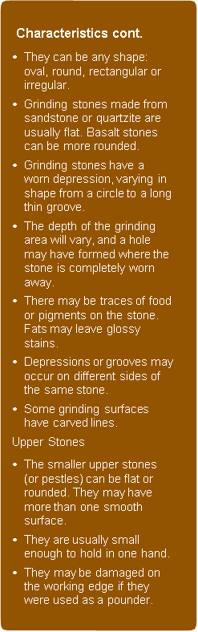

June 2008

Copyright State Government of Victoria 2008. Authorised by the Victoria Government, Melbourne

ISBN 978-1-921331-60-2

This publication may be of assistance to you but the State of Victoria and its employees do not guarantee that the publication is without flaw of any kind or is wholly appropriate for your particular purposes and therefore disclaims all liability for any error, loss or other consequence which may arise from you relying on any information in this publication.  
<https://www.vic.gov.au/aboriginalvictoria/heritage.html>

cid:image001.png@01D4A28E.A22CFCA0